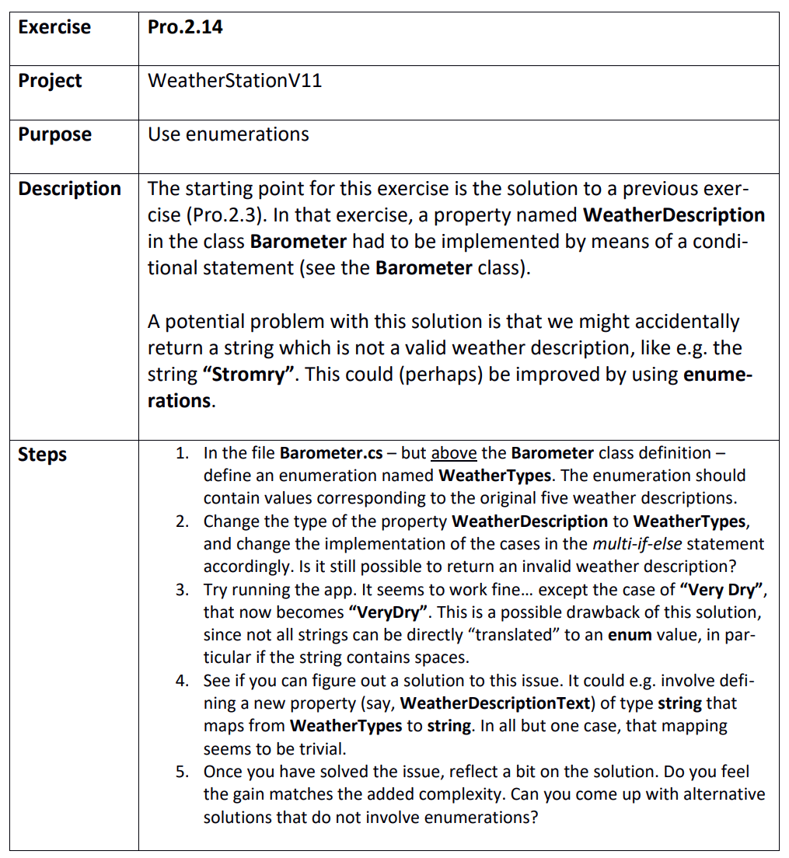

Step 1
WeatherStationV11.sln
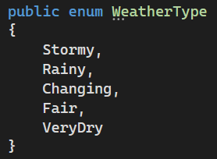

Step 2
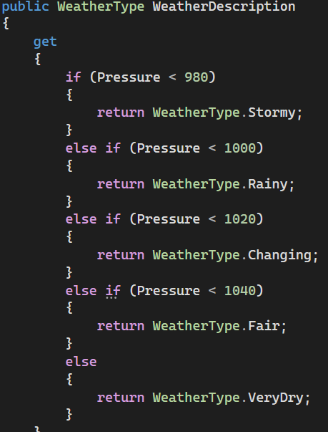
It is no longer possible to return an invalid description

Step 3
True thing

Step 4 & 5
Use underscore for spaces
